**Voter ID: Your Guide**

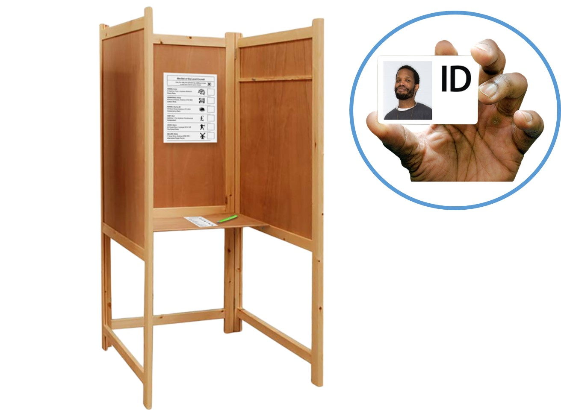**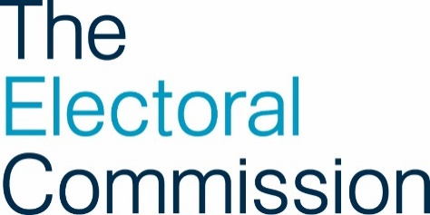Everything you need to know about photo ID**

**Contents**

Introduction 2

How do I register to vote? 2

Which elections do I need photo ID for voting?...........5

ID for voting 6

Applying for a **Voter Authority Certificate** 9

Voting at the **polling station** 14

Other ways to vote 18

More information 21

Words used in this easy read 25

# **Introduction**

In the UK the law says you have to show photo ID when voting at a polling station in some elections.

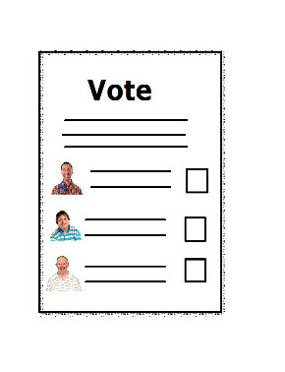

This document tells you what you need to know about photo ID and voting at a polling station.

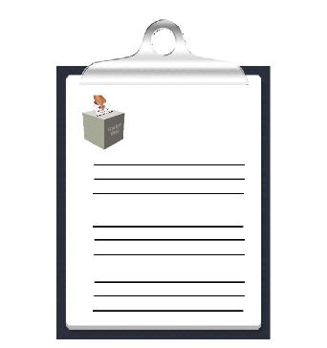

# **How do I register to vote?**

Before you can vote in an election, you must register to vote.

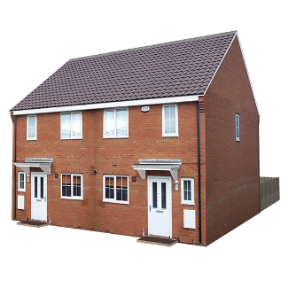

If you have moved to a different address



or changed your name since you registered

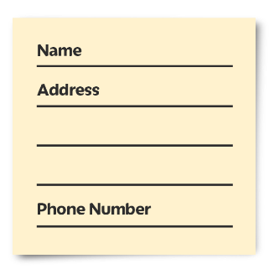you will need to update your details.

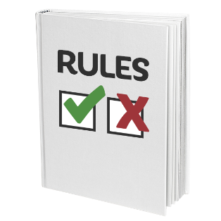

The rules about who can register to vote are different depending on where you live.



You can find out more on the [Electoral Commission's website www.electoralcommission.org.uk/voter](http://www.electoralcommission.org.uk/voter)



You can register to vote, or update your details on the [Government’s website](https://www.gov.uk/register-to-vote) [www.gov.uk/register-to-vote](http://www.gov.uk/register-to-vote)

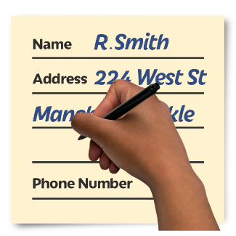

or you can fill in a paper application form.

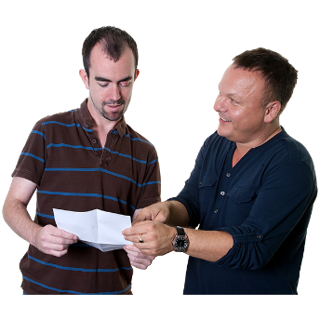If you:

* need help to register to vote
* need help to update your details
* or want a paper application form

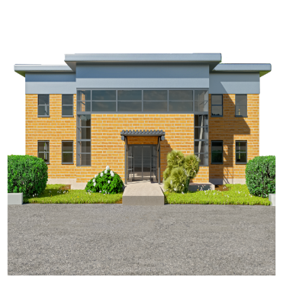

contact your local Electoral Registration Officer



To find the contact details for your local Electoral Registration Officer, go to the [Electoral Commission’s website](https://www.electoralcommission.org.uk/i-am-a/voter/your-election-information) [www.electoralcommission.org.uk/voter](http://www.electoralcommission.org.uk/voter)



or phone our helpline on **0800 328 0280**.



If you are currently homeless, or are a member of a Gypsy, Roma or Traveller community, you can still register to vote.

To find out how, visit [www.electoralcommission.org.uk/voter](http://www.electoralcommission.org.uk/voter)





or phone our helpline on 0800 328 0280.

**Which elections do I need photo ID**

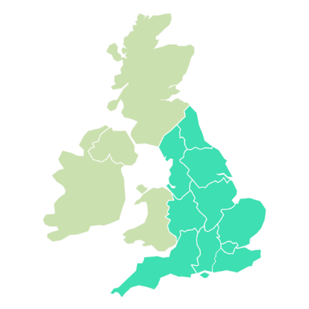 **for voting?**

If you live in England, you need photo ID to vote at a **polling station** for:

* UK Parliament general elections (from October 2023)
* UK Parliament by-elections and recall petitions
* Local council elections and by-elections
* Police and Crime Commissioner elections

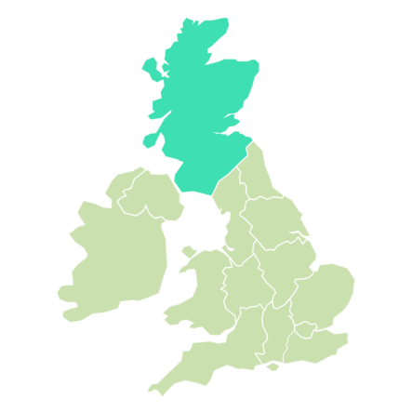

If you live in Scotland, you need photo ID to vote at a **polling station** for:

* UK Parliament general elections (from October 2023)
* UK Parliament by-elections and recall petitions

You do not need photo ID in Scotland to vote at a **polling station** in:

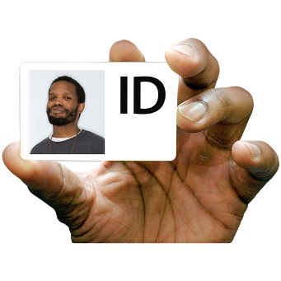

* Scottish Parliament
* Council elections and by-elections

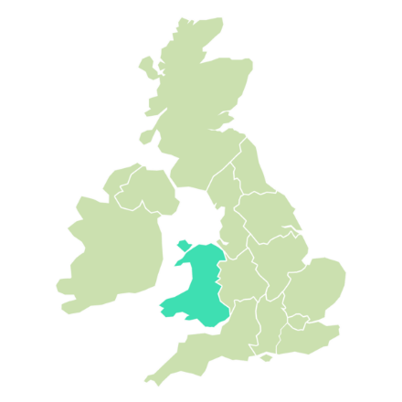

If you live in Wales, you need to take photo ID to vote a **polling station** for:

* UK Parliament general elections (from October 2023)
* UK Parliament by-elections and recall petitions
* Police and Crime Commissioner elections



You do not need photo ID in Wales to vote at a **polling station** in:

* Senedd elections
* Council elections and by-elections

# 

# **ID for voting**

If you are voting at a **polling station** in an election where you will need to show photo ID you will need to show photo ID,

you will need to show 1 form of ID from this list:

* passport
* driving licence (a provisional licence is ok)
* Blue badge
* identity card with **PASS mark**
* biometric immigration document
* defence identity card

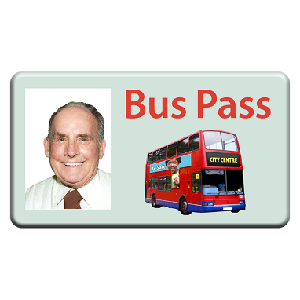

Some concessionary travel cards and some national identity cards are ok.

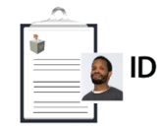

The name on your photo ID should be the same name you used to register to vote.

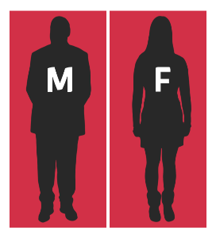

You do not need to show photo ID that includes a **gender** marker.

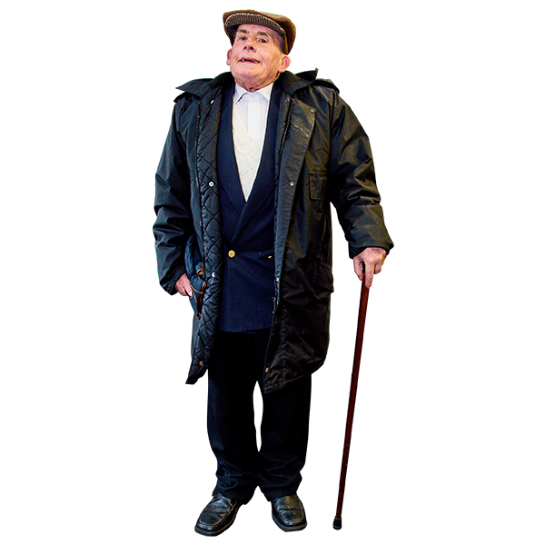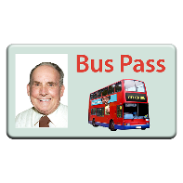

If your photo ID is out of date, it is ok to use it if the photo still looks like you.



For more information about what you can use as photo ID, go to the [Electoral Commission’s website](http://www.electoralcommission.org.uk/voterID) [www.electoralcommission.org.uk/voterID](http://www.electoralcommission.org.uk/voterID)



or phone our helpline on **0800 328 0280**.

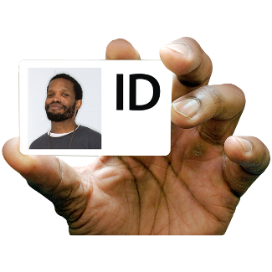

If you do not have any of the ID on the list,



or you are not sure if your photo ID still looks like you



you can apply for a **Voter Authority Certificate**.

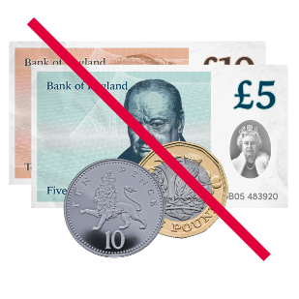A **Voter Authority Certificate** is free.



You will be able to use your **Voter Authority Certificate** as photo ID when you vote at a **polling station**.

# **Applying for a Voter Authority Certificate**

You need to be registered to vote before you can apply for a **Voter Authority Certificate**.

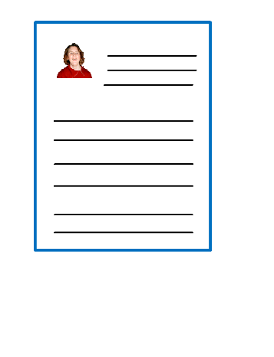

If you need a **Voter Authority Certificate** to vote

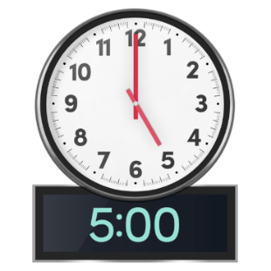

you must apply for the certificate by 5pm 6 working days before the date of that election.

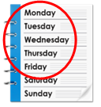Working days are usually Monday, Tuesday, Wednesday, Thursday and Friday.

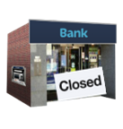

Do not count a day as a working day if it is a public holiday.  For example, Good Friday is a public holiday.

It is a good idea to apply as soon as possible in case your local council needs to check any details with you.



You can apply for a **Voter Authority Certificate** online on [the Government’s website](https://www.gov.uk/apply-for-photo-id-voter-authority-certificate) [www.gov.uk/apply-for-photo-id-voter-authority-certificate](http://www.gov.uk/apply-for-photo-id-voter-authority-certificate)



or by filling in a paper application form.



If you need help to apply for a **Voter Authority Certificate**, or want a paper application form



contact your local Electoral Registration Officer .



To find the contact details for your local Electoral Registration Officer go to the [Electoral Commission’s website](https://www.electoralcommission.org.uk/voter) [www.electoralcommission.org.uk/voter](http://www.electoralcommission.org.uk/voter)



or phone our helpline on **0800 328 0280**.

****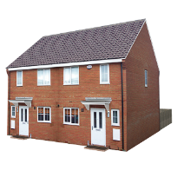When you apply for your **Voter Authority Certificate**, you will need to know your:

* name
* address
* date of birth

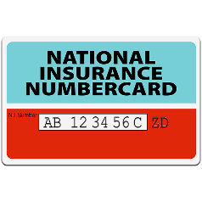

It is a good idea if you know your National Insurance Number when you apply for your **Voter Authority Certificate**.

You can apply for a **Voter Authority Certificate** if you do not know your National Insurance Number.

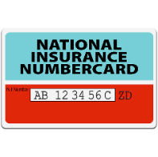

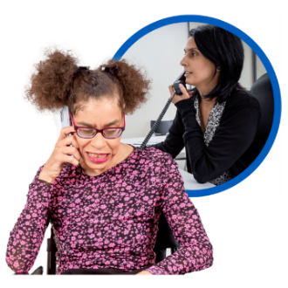

If you do not know your National Insurance Number, your local Electoral Registration Officer will contact you to ask for something else to prove your identity.



When you apply for a **Voter Authority Certificate**, you will need to send a photo with the form.

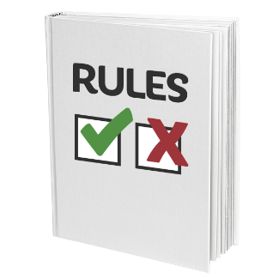

There are rules about the photo you can send.



The rules are like the rules for a passport photo.

If you do not have a photo which keeps to the rules, your local Electoral Registration Office may be able to take a photo for you.



To find out more about the rules for the photo, go to the [Electoral Commission’s website](https://www.electoralcommission.org.uk/voterID) [www.electoralcommission.org.uk/voterID](http://www.electoralcommission.org.uk/voterID)



or phone our helpline on **0800 328 0280**.

# **Voting at the polling station**

When you arrive at the **polling station**, a member of staff will ask you for your name and address.

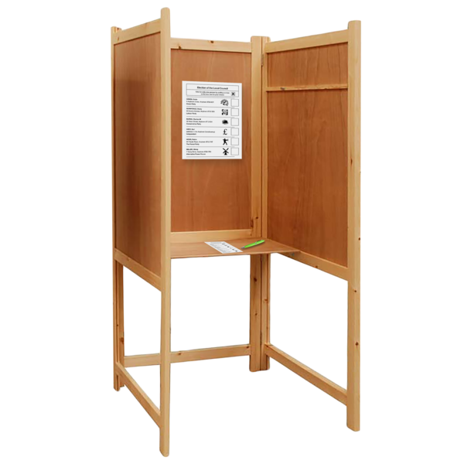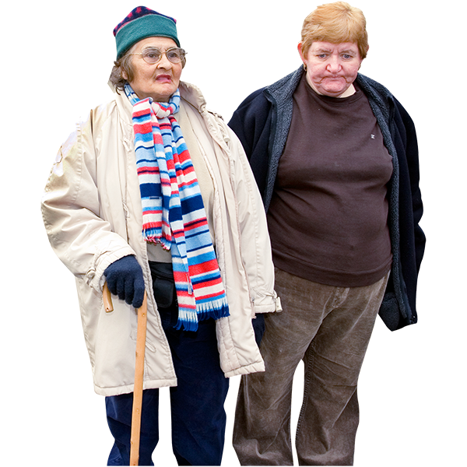

You can also take someone with you to the **polling station** if you need help to vote.

For more information visit the [Electoral Commission website www.electoralcommission.org.uk/voter](http://www.electoralcommission.org.uk/voter)



They will look for you on the voting register.

They will ask for your photo ID.

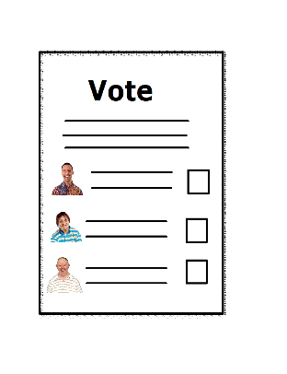

If they are happy with your photo ID, they will give you your **ballot paper** and let you know where you can fill it in.



There will be a private area at the **polling station** where staff can look at your photo ID.



If you want the staff to look at your photo ID in the private area of the **polling station**, let them know when you arrive at the **polling station**.

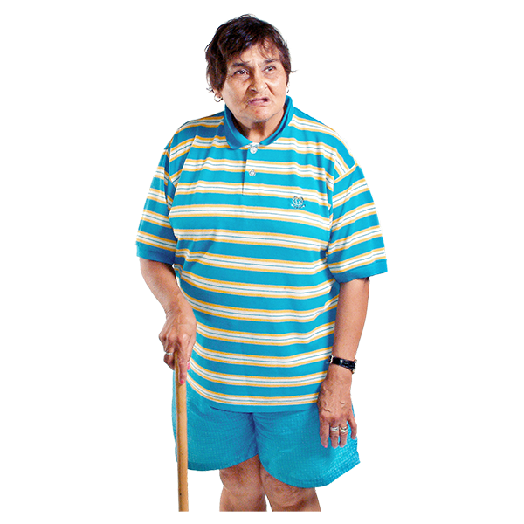

You can ask for a female member of staff to check your photo ID.



The staff at the polling station will try to make sure this happens.

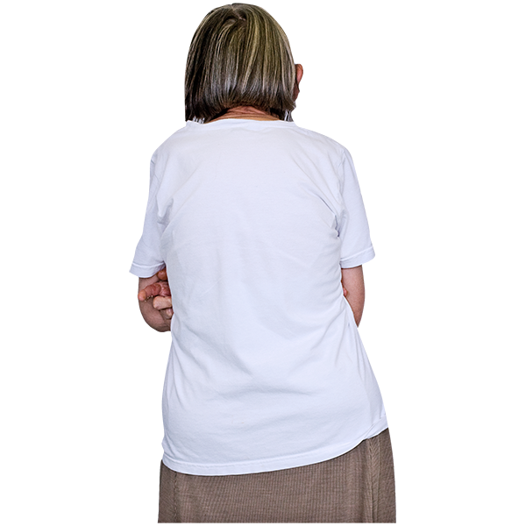

If you wear a face covering for medical reason and would prefer not to remove it indoors, staff may be able to check it outside.



If you wear a face covering such as a veil, there will be a mirror available for you to put it back on again.

If you need any help when you are at the **polling station**, please ask the staff.

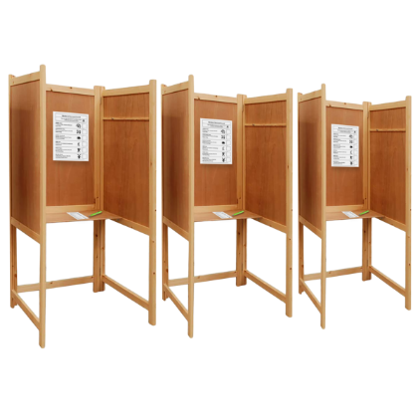



Your local council might be able to provide extra equipment to help you vote.



If you need some extra equipment to help you to vote, contact your local council to ask them if they can have it at your polling station.

# **Other ways to vote**



**Voting by post**

If you want to vote by post, you will need to fill in an application form.



Your local council must have your form by 5pm, 11 working days before the date of that election. .



You do not need to have photo ID to vote by post.

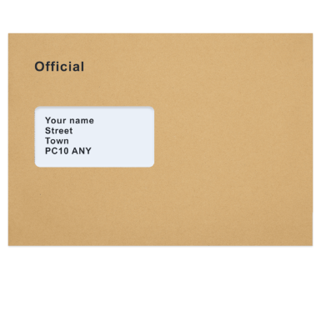

Your **ballot paper** will arrive in the post.

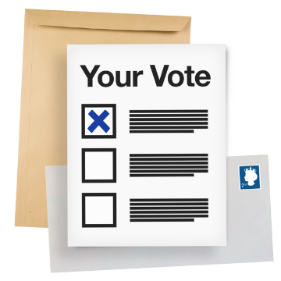Fill in the **ballot paper** and send it back to your local council in your postal vote pack.

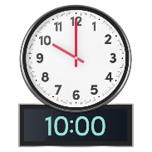

Your local council must have your postal vote packby 10pm on the day of the election.

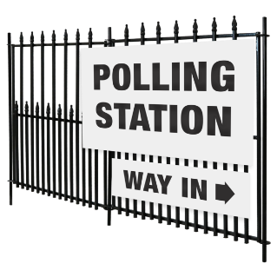

If there is not enough time to post your postal vote pack, you can take it to your **polling station** or local council office on the day of the election.



**Voting by proxy**

If you want to vote **by proxy**, you will need to fill in an application form.

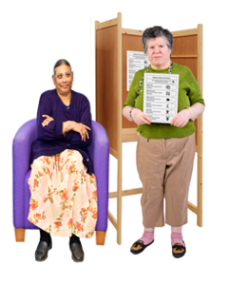If you will not be able to go to the polling station on election day, you can choose to have someone you trust vote on your behalf. This is called 'voting by **proxy**

Your local council must have your form 6 working days before the date of that election.



The person you choose to vote for you will need to go to your **polling station** to vote.

They will need to show their photo ID.







They will not need to show your photo ID to vote for you.

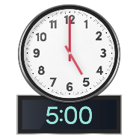

If you cannot go to the **polling station** because of an emergency, you can apply for an emergency proxy until 5pm on the day of that election..



For more information, or to get a postal or **proxy** application form, go to the [Electoral Commission’s website](https://www.electoralcommission.org.uk/voter) [www.electoralcommission.org.uk/voter](http://www.electoralcommission.org.uk/voter)



or phone our helpline on **0800 328 0280**.

# **More information**

If you have any questions about:

* registering to vote
* photo ID
* how to apply for a **Voter Authority Certificate**
* or would like this information in a different format,



go to the [Electoral Commission’s website](https://www.electoralcommission.org.uk/voter) [www.electoralcommission.org.uk/voter](http://www.electoralcommission.org.uk/voter)

or phone our helpline on **0800 328 0280**.

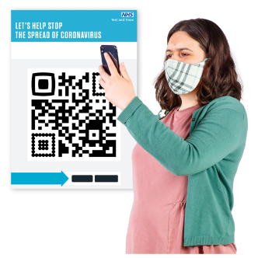You can also scan the QR code below. The QR code will take you to the Electoral Commission website.



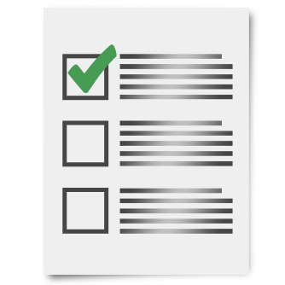

You might want to use the checklist below to check you are ready to vote



Have I registered to vote?

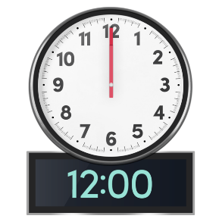You must register to vote by 1 minute before midnight at least 12 working days before the date of an election.

Do I have photo ID?



If not, have I applied for a **Voter Authority Certificate**?



You must apply for your **Voter Authority Certificate** by 5pm, 6 working days before the date of that election.



Do I have my photo ID ready to take to the **polling station** with me on election day?

This document has been produced by the Electoral Commission.



The Electoral Commission makes sure that elections in the UK run properly.

# **Words used in this easy read**

**ballot paper** The piece of paper you fill in to vote.

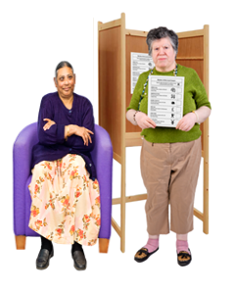

**by proxy** If you do something by proxy, you are doing it for someone else. If you vote by proxy, it means you ask someone you trust to vote for you.

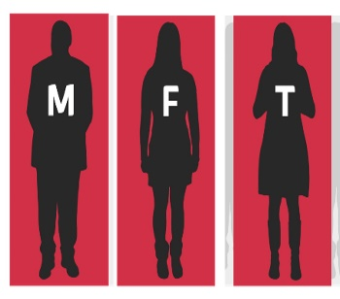

**gender** Gender is how we think of ourselves.  This might be male or female, or both, or neither.



**PASS mark** PASS stands for Proof of Age Standards Scheme. If an organisation has an ID card with a PASS mark, it means that the organisation has been checked. The police think the PASS mark is a good idea.



**polling station** The place you go to vote in an election.



**Voter Authority Certificate** A free document you can get to use as photo ID for voting in an election.